SoftKeyboard Localization MINI-HOWTO
Hong Chen

Reference: How to: Localize an Application
The document in the below link is the official document for doing localization for WPF. I suggest you read it.
http://wcpsdk/wpf_conceptual/html/5001227e-9326-48a4-9dcd-ba1b89ee6653.htm

Key steps:
I will use Chinese culture as an example.

- Add <UICulture>en-US</UICulture> to project file and rebuild the project.
The compiler will separate those cultural sensitive parts from the neutral parts and generate a satellite assembly with name keyboard.resources.dll in folder ‘en-US’. Now your bin folder will looks like
bin\Debug\Keyboard.dll
bin\Debug\Keyboard.pdb
bin\Debug\en-US\Keyboard.resources.dll

- Add Uids to XAML files.
msbuild /t:updateuid keyboard.csproj

- Copy all necessary files to one folder. The LocBaml can be found from my sample under Localize folder or follow the reference link to build one
Localize\LocBaml.exe
Localize\Keyboard.dll
Localize\Keyboard.resources.dll

- Use LocBaml to extract the text content that will be localized.
LocBaml.exe /parse keyboard.resources.dll /out:keyboard.csv

- Translate the Localizable Content. And save it.

- Use LocBaml to generate a new .resources.dll File
LocBaml.exe /generate Keyboard.resources.dll /trans:keyboard.csv /out:zh-CN\ /cul:zh-CN

- Put the generated satellite assembly in a folder with a name same as its UICulture (e.g. “zh-CN” in this example) and side by side with the folder “en-US”

How to test:
Launch the application in a Chinese Windows XP, or, change the thread’s UICulture to ‘zh-CN’ (see line 18 in test\MyApp.xaml.cs) and update the Language property (line 24 in test\Window1.xaml.cs).

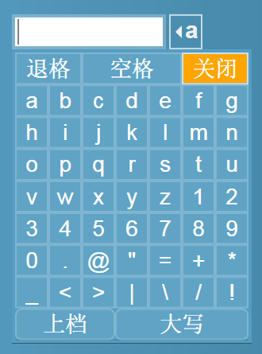

NOTE:
Every time you make change to the keyboard project, you probably need to re-do the above 7 steps. So start localization only when your code is stable enough.

